|  |  |  |  |
| --- | --- | --- | --- |
|  | **1.2.3 Practice: Comparing Economic Systems** | | Practice |
| Economics | Name: |  |
| Date: |  |

For this assignment, you will complete the following steps:

1. **Review**: Look back over your notes on the types of economies.
2. **Evaluate**: Consider what life would be like in each type of economic system.
3. **Write**: Complete the questions below.

To get the best grade possible, follow the instructions in the assignment closely and answer all the questions completely. This assignment is worth 10 points.



**Use your notes on the different types of economic systems to help you answer the questions below.**

**This section is worth 6 points.**

1. How does each type of economy answer the three basic economic questions? (3 points)

Command:

Market:

Mixed:

2. Place each of the economies described on page 3 on the spectrum of economic systems below. (3 points)

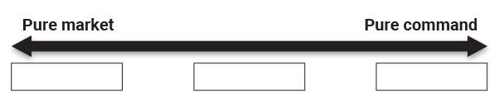



**You will now write a brief evaluation of the three economic systems outlined on page 3. Be specific about what aspects of the economy would make living there desirable or undesirable.**

**This section is worth 4 points.**

3. Which of the three economies described on page 3 would you most like to live in? Which would you least like to live in? Explain your reasons for each choice.

Most like to live in:

Explanation:

Least like to live in:

Explanation:

Copyright © 2022 Apex Learning Inc. Use of this material is subject to Apex Learning's [Terms of Use](http://www.apexlearning.com/Terms_of_Use_Customer_Websites.htm). Any unauthorized copying, reuse, or redistribution is prohibited. Apex Learning ® and the Apex Learning Logo are registered trademarks of Apex Learning Inc.

1.2.3 Practice: Comparing Economic Systems